**Farm Cooperative**

By Raymond Hua and George Alexander

# Use Cases

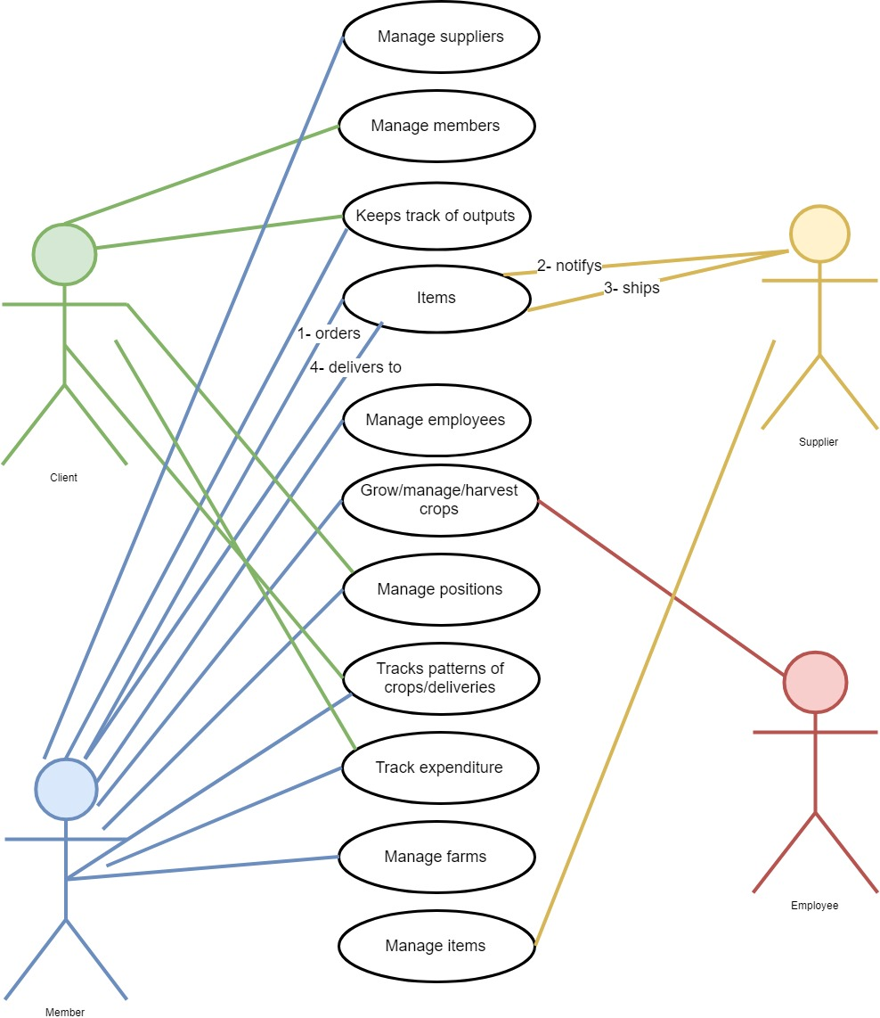

The client can…

* Manage
  + Members
  + Positions
  + Track patterns of crops/deliveries
* Keep track of outputs
* Track expenditure

The member/manager can…

* Manage
  + Suppliers
  + Positions
  + Farms
  + Track patterns of crops/deliveries
* Keep track of outputs
* Grow, manage, harvest crops
* Track expenditure

The employee can…

* Grow, manage, harvest crops

Items

1. The member orders the supplies (e.g. equipment)
2. The supplier gets notified – via Email
3. The supplier ships them to the member
4. The member receives the supplies

# ERD

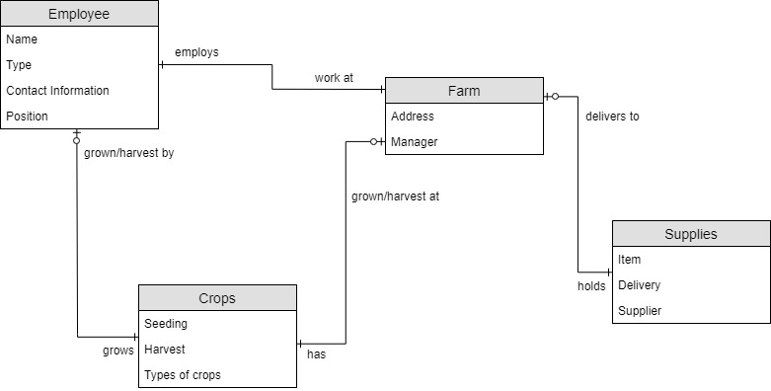

We separate into four sections

* Employees
* Crops
* Farm
* Supplies

# 3rd Normal Form

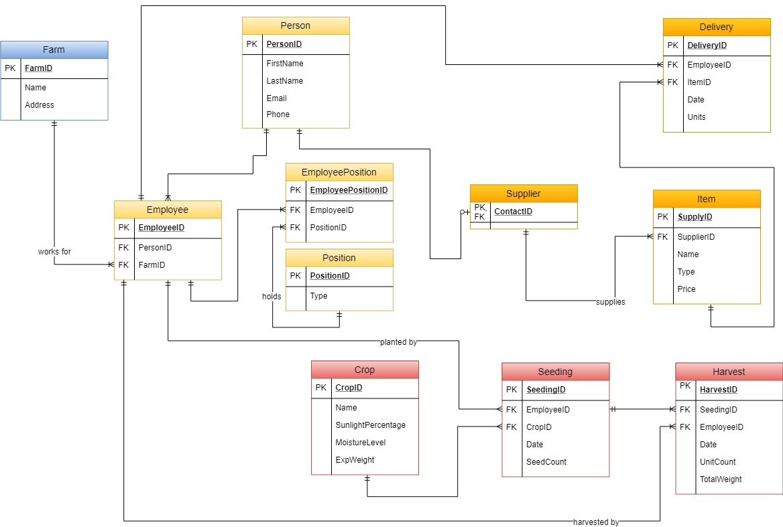

**Notes**

**Person**

* Reduce code duplication
* The employee can hold multiple positions
* The employee can work for multiple farms

**Supplier**

* They can be anyone (e.g. employee, manager, client)
* Type in the Item table (e.g. equipment, etc.)

**Crop**

* The person who harvest the crops might not be the one who grew them
* Harvesting the same crops at separate occasions

# Data Dictionary

|  |  |  |
| --- | --- | --- |
| Farm | | |
| Field Name | Data Type | Description |
| FarmID (PK) | Integer | This is the unique identifier for each farm in the system. |
| Name | Varchar | Field used to store the name of each farm. |
| Address | Varchar | Field used to store the address of each farm. |

|  |  |  |
| --- | --- | --- |
| Employee | | |
| Field Name | Data Type | Description |
| EmployeeID (PK) | Integer | Unique identifier for each employee in the system. |
| PersonID (FK) | Integer | Foreign key references PersonID in the Person table |
| FarmID (FK) | Integer | Foreign key references FarmID in the Farm table |

|  |  |  |
| --- | --- | --- |
| EmployeePosition | | |
| Field Name | Data Type | Description |
| EmployeePositionID (PK) | Integer | Unique identifier for employee position |
| EmployeeID (FK) | Integer | Foreign Key references EmployeeID in the Employee table |
| PositionID (FK) | Integer | Foreign Key references PositionID in the Position table |

|  |  |  |
| --- | --- | --- |
| Position | | |
| Field Name | Data Type | Description |
| PositionID(PK) | Integer | Unique Identifier for position |
| Type | Varchar | Holds the specific type of position. E.g. Farm Manager, Consultant, Plant Breeder etc. |

|  |  |  |
| --- | --- | --- |
| Person | | |
| Field Name | Data Type | Description |
| PersonID (PK) | Integer | Unique identifier for each person in the system |
| FirstName | Varchar | Holds the first name of the person |
| LastName | Varchar | Holds the last name of the person |
| Email | Varchar | Holds the email of the person |
| Phone | Integer | Holds the phone number of the person |

|  |  |  |
| --- | --- | --- |
| Supplier | | |
| Field Name | Data Type | Description |
| ContactID (PK) (FK) | Integer | Unique identifier for the supplier |

|  |  |  |
| --- | --- | --- |
| Delivery | | |
| Field Name | Data Type | Description |
| DeliveryID (PK) | Integer | Unique identifier for each delivery |
| EmployeeID (FK) | Integer | Foreign Key references EmployeeID in the Employee table |
| ItemID (FK) | Integer | Foreign Key references ItemID in the Position table |
| Date | Date/Time | Used to store the date of each delivery in the system |
| Units | Integer | Holds the number of units distributed in each delivery e.g 5 bags of carrots |

|  |  |  |
| --- | --- | --- |
| Item | | |
| Field Name | Data Type | Description |
| SupplyID (PK) | Integer | Unique identifier for supply |
| SupplierID (FK) | Integer | Foreign Key references supplierID in the Supplier table |
| Type | Varchar | Type of item (e.g. equipment) |
| Name | Varchar | Used to store the name of each item in the database |
| Price | Integer | The price of each particular item. |

|  |  |  |
| --- | --- | --- |
| Crop | | |
| Field Name | Data Type | Description |
| CropID (PK) | Integer | Unique identifier for each crop |
| Name | Varchar | Stores the name of crop. E.g. Carrots |
| SunlightPercentage | Integer | Stores the percentage of sunlight. |
| MoistureLevel | Integer | Stores the moisture level |
| ExpWeight | Integer | Stores the expected weight |

|  |  |  |
| --- | --- | --- |
| Seeding | | |
| Field Name | Data Type | Description |
| SeedingID (PK) | Integer | Unique identifier for seeding |
| EmployeeID (FK) | Integer | Foreign Key references EmployeeID in the Employee table |
| CropID (FK) | Integer | Foreign Key references CropID in the Crop table |
| Date | Date/Time | Stores the date for when the crops were planted |
| SeedCount | Integer | Number of seeds planted |

|  |  |  |
| --- | --- | --- |
| Harvest | | |
| Field Name | Data Type | Description |
| HarvestID(PK) | Integer | Unique identifier for harvest |
| SeedingID (FK) | Integer | Foreign Key references SeedingID in the Seeding table |
| EmployeeID (FK) | Integer | Foreign Key references EmployeeID in the Employee table |
| Date | Date/Time | Stores the date of when the seeds were harvested |
| Unit Count | Integer | Stores the number of units counted |
| TotalWeight | Integer | Stores the total weight of the harvest |